Title : **Chatbot to shop for essentials during pandemic using Watson Assistant**

Submitted by : Poonam shah

Most chatbots try to mimic human interactions, which can frustrate users when a misunderstanding arises. Watson Assistant is more. It knows when to search for an answer from a knowledge base, when to ask for clarity and when to direct users to a human. Watson Assistant can be deployed in any cloud or on-premises environment – meaning smarter AI is finally available wherever you need it.

**STEPS:**

**Create intents:**

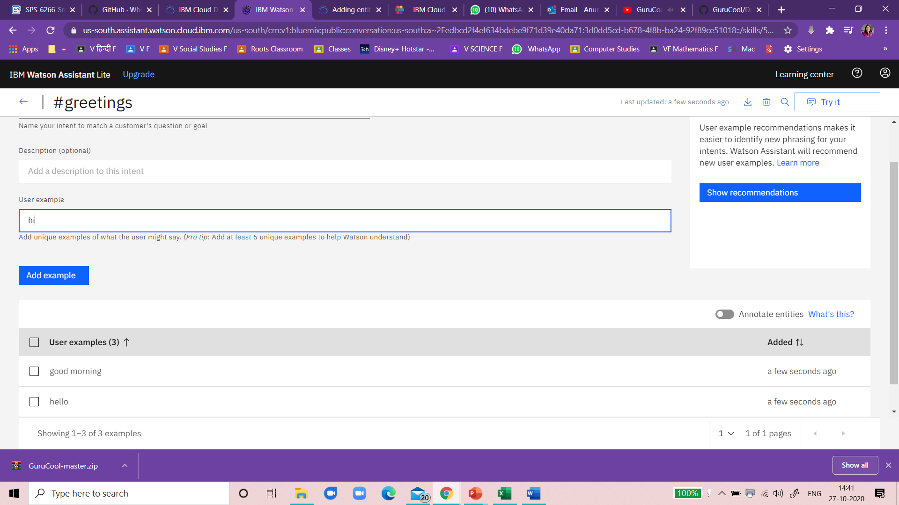

Create Entities:

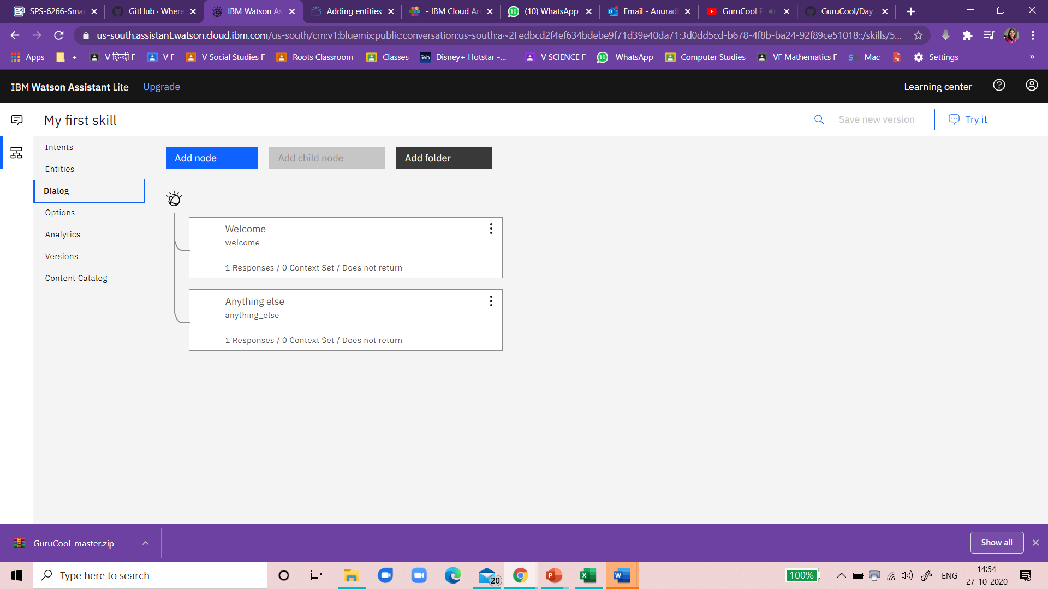

Add assistant Response

